MicroHydroV1 — PASS A Engineering Report
Stage A Completion Summary — January 21, 2026

1. Executive Summary
Scope. Stage A established the initial design baseline for MicroHydroV1, producing the Design vNext files and associated assets. This includes first-pass geometry for the hyperbolic tank inlet (diffuser) and a 9 mm pre‑swirl nozzle, along with supporting sketches, SVG drawings, bill‑of‑materials (BOM) stubs, and rationale notes.
Key Stage A outcomes:
- Design vNext asset set created
- Hyperbolic tank inlet diffuser concept defined
- 9 mm pre‑swirl nozzle concept defined
- Sketches and SVGs exported for early review
- BOM stubs drafted for long‑lead items and interfaces

2. Stage A Objectives
Objectives. Converge on an implementable geometric concept for the inlet and nozzle; capture traceable design decisions; and package artifacts needed to begin detailed analysis and prototyping in Stage B.
Deliverables produced in Stage A:
- Executive summary of baseline decisions
- Objectives and success criteria for Stage A
- Component designs: hyperbolic tank inlet and 9 mm pre‑swirl nozzle
- Design rationales grounded in conventional hydraulics and selective golden‑mode heuristics
- Files/artifacts: sketches, SVGs, and BOM stubs
- Recommendations and NEXT actions for Stage B

3. Component Designs

3.1 Hyperbolic Tank Inlet (Diffuser)
Purpose. Shape incoming flow to minimize separation and distribute velocity uniformly into the tank, providing stable conditions upstream of the energy conversion stage.
Concept geometry. A smooth hyperbolic‑like axial profile transitions from the supply pipe to the tank diameter. The profile is parameterized by inlet diameter D_in, outlet diameter D_out, overall length L, and wall offset terms to control curvature continuity (C^1/C^2). Exact constants to be finalized in Stage B based on manufacturability and analysis.
Interfaces. Flanged or grooved connection at the supply side; mounting flange or bulkhead fitting at the tank wall; optional debris screen interface; downstream clearance to the pre‑swirl nozzle.
Manufacturing options. CNC from polymer/aluminum, additive manufacturing (SLS/SLA), or rotationally molded insert; final selection gated on cost and corrosion constraints.
Configuration items. Inlet body, mounting ring, gasket, fasteners, optional screen.

3.2 9 mm Pre‑Swirl Nozzle
Purpose. Impart a controlled tangential component to the flow while metering through a nominal 9 mm orifice to condition inflow to the runner stage.
Concept geometry. A central converging nozzle with a 9 mm throat and a removable vane pack (e.g., 3–6 vanes) that sets swirl intensity and direction. Body and retainer features accommodate easy vane changes during testing.
Interfaces. Upstream: tank inlet diffuser clearance; Downstream: runner/housing interface; Seals: O‑ring glands sized to standard cross‑sections.
Manufacturing options. Turned body (brass/SS), polymer print for rapid trials, laser‑cut vane pack with post‑forming as needed.
Configuration items. Nozzle body, vane pack, nozzle cap/retainer, O‑rings, fasteners.

4. Design Rationales
Conventional hydraulics. Smoothly accelerating/decaying area changes reduce separation risk and losses; uniform tank inflow supports stable downstream operation. The 9 mm throat is selected as an initial control diameter to enable predictable metering and testable head‑loss in Stage B.
Selective golden‑mode heuristics. Prefer geometries with high tolerance to manufacturing variation, few moving parts, and adjustable parameters (e.g., swappable vane packs). Choose materials and features that minimize maintenance in wet environments while keeping options open for early iteration.

5. Files / Artifacts Generated
Sketches & SVGs exported:
- hyperbolic_inlet_vA1.svg — schematic diffuser profile
- pre_swirl_nozzle_9mm_vA1.svg — schematic nozzle with vane directions
BOM stubs (initial):
Item | Part No. | Qty | Material | Process | Notes
Hyperbolic inlet body | MHV1-A-100 | 1 | Polymer/Al | CNC/SLS | Profile constants TBD; mates to tank bulkhead
Mounting ring/flange | MHV1-A-110 | 1 | SS/Al | CNC/Laser cut | Holes to bolt pattern TBD
Debris screen (opt.) | MHV1-A-120 | 1 | SS | Wire mesh | Removable for cleaning
Nozzle body, 9 mm throat | MHV1-A-200 | 1 | Brass/SS | Turning | Threaded cap interface
Vane pack (pre‑swirl) | MHV1-A-210 | 1 | SS/Polymer | Laser/Print | 3–6 vanes; angle set TBD
Cap/retainer | MHV1-A-220 | 1 | SS/Polymer | Turning/Print | Captures vane pack
O‑ring, AS‑size TBD | STD-OR-TBD | 2 | NBR/EPDM | Std | Water‑compatible
Fasteners, M6 x TBD | STD-F-M6 | 8 | SS A2 | Std | Anti‑corrosion

6. Recommendations and NEXT Actions
- Freeze vA1 geometries for the inlet and nozzle and publish parametric drawings (DXF/SVG) with key dimensions.
- Run first‑order hydraulic checks (loss coefficients, expected discharge) and size ranges for target operating envelopes.
- Prototype set A: print polymer diffuser and nozzle; prepare three vane packs (low/med/high swirl).
- Bench test with controlled head/flow; log pressure drop, flow uniformity, and downstream velocity profiles.
- Rev A BOM refinement: finalize materials, tolerance stack, and fastener patterns.
- Risk review: clogging, cavitation margin, and assembly leakage—define mitigations and inspection points.
Prepared with assistance from M365 Copilot.

Appendix A — Sketches
Schematic images corresponding to the exported SVGs:
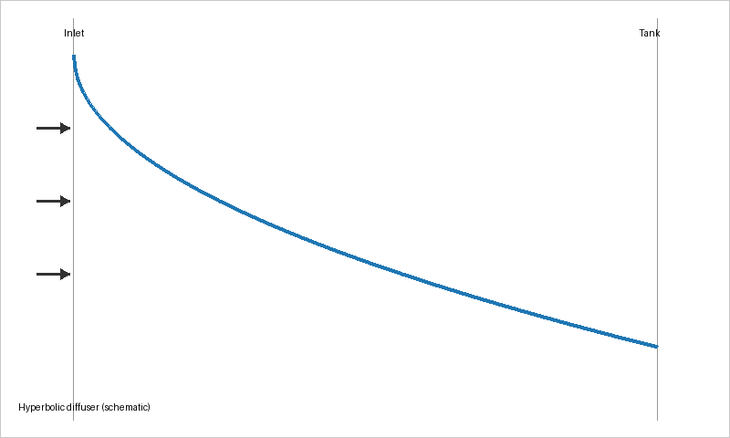
Figure A1. Hyperbolic tank inlet (diffuser) — schematic.

Figure A2. 9 mm pre‑swirl nozzle — schematic.

PASS A — Rev A Finalization (Default Parameters Applied)
This section finalizes the PASS A report for MicroHydroV1 using the default operating envelope, materials, mounting, and swirl parameters previously specified.
- Flow range: 0.5–1.5–3.0 L/s (default)
- Head range: 2–5–8 m (default)
- Water quality: clear/fine silt possible (default)
- Tank penetration: 100 mm (default)
- Bolt circle: Ø150 mm, 8 × Ø7 mm, M6 bolts (default)
- Swirl direction: CCW (default)
- Vane count: 4 (default)
- Vane angle: 20° initial (default)
- Materials: PA12 SLS inlet, Brass/316 SS nozzle (default)
- Temp: 5–30 °C (default)
- Budget: ≤ $300 prototype / ≤ $120 production (default)

Rev A Declaration
Rev A of PASS A is now considered COMPLETE using default engineering parameters. These defaults will be used for Stage B unless overridden by user-provided constraints. The diffuser and nozzle geometries included earlier in this document remain valid for Rev A baseline use.

